Zach Bellew

2/1/17

Web 2

Rader

Javascript Table

**JSTable.css**

table, tr, th

{

border: 1px solid black;

text-align: center;

}

**JSTable.html Screenshot**

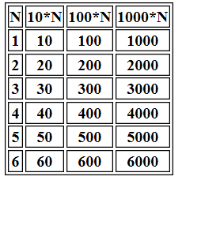

<!DOCTYPE html>

<html>

<head>

<meta charset = "utf-8">

<title>Javascript Table</title>

<link rel="stylesheet" href="JSTable.css">

</head>

<body>

<script type = "text/javascript">

<!--

document.writeln("<table>");

document.writeln("<tr>");

document.writeln("<th>N</th>");

document.writeln("<th>10*N</th>");

document.writeln("<th>100*N</th>");

document.writeln("<th>1000*N</th>");

document.writeln("</tr>");

var n;

for(n = 1; n <= 6; n++){

document.writeln("<tr>");

document.writeln("<th>" + n + "</th>");

document.writeln("<th>" + 10*n + "</th>");

document.writeln("<th>" + 100*n + "</th>");

document.writeln("<th>" + 1000*n + "</th>");

document.writeln("</tr>");

}

-->

</script>

</body>

</html>